**GeoLocation Assignment**

1. **Spatial Database (csv file uploaded) :-**

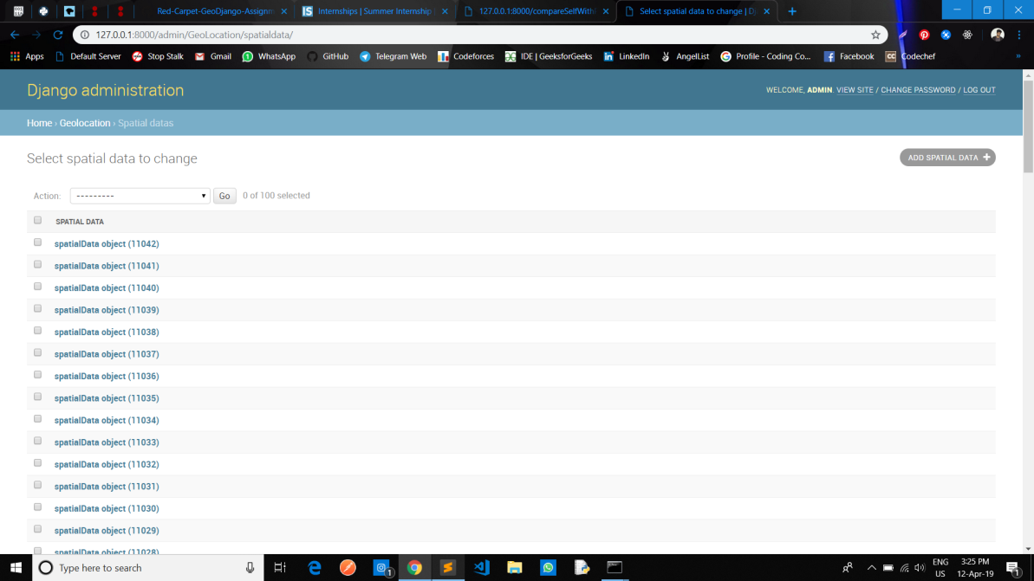

1. **After doing this visit the endpoint /addPoint and the data which had no latitudes longitudes were discarded as they were of no use. For the rest , each entry looks like this:-**

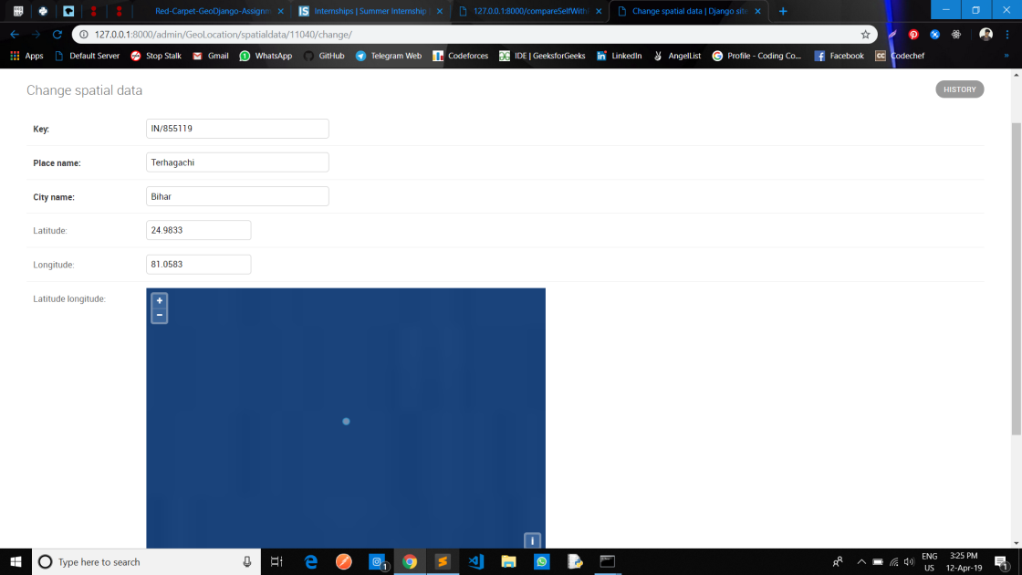

1. **Then visit the /get_using_self with the query parameter:- ?n1=32&n2=24.9833&n3=81.0583**

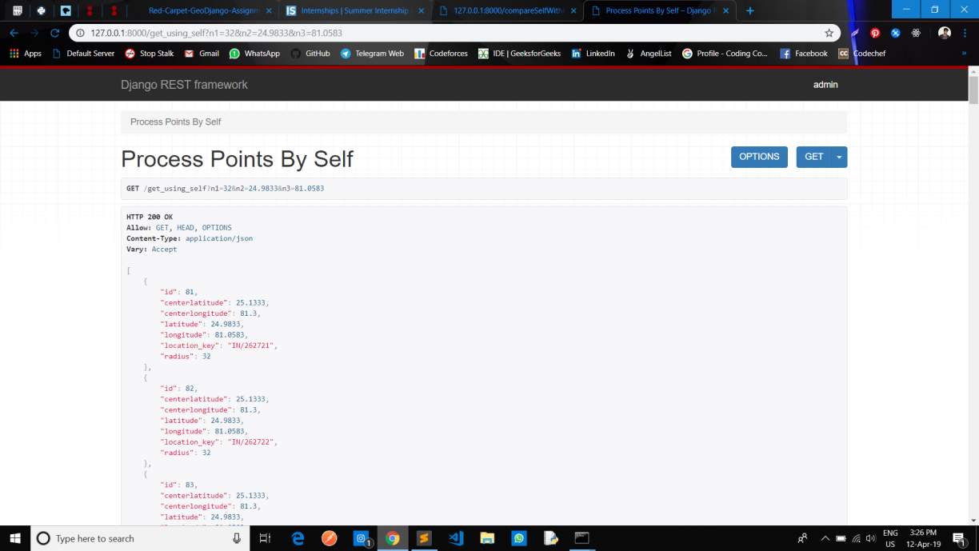

1. **Then visit the /get_using_Postgres with the same query parameter:- ?n1=32&n2=24.9833&n3=81.0583**

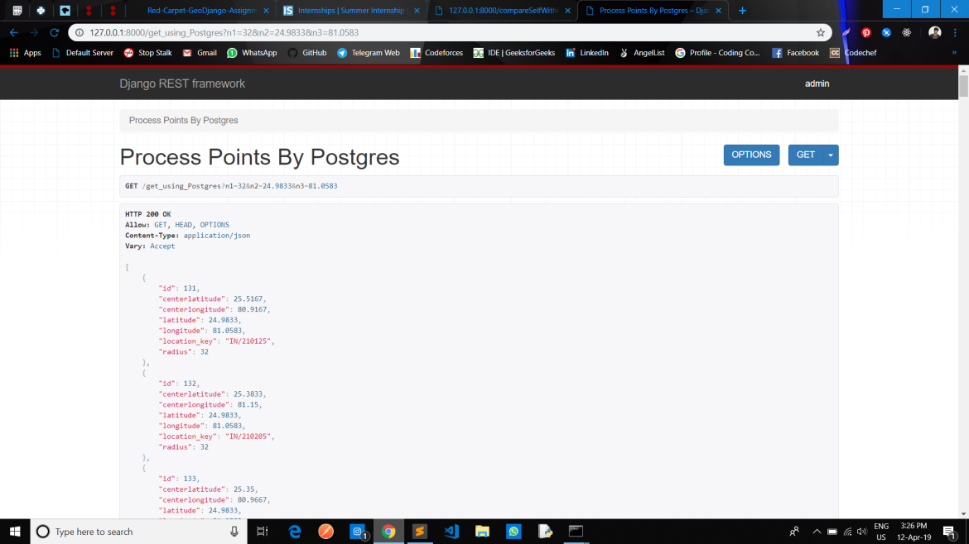

1. **Then visit the / compareSelfWithPostgres to see the comparison:-**

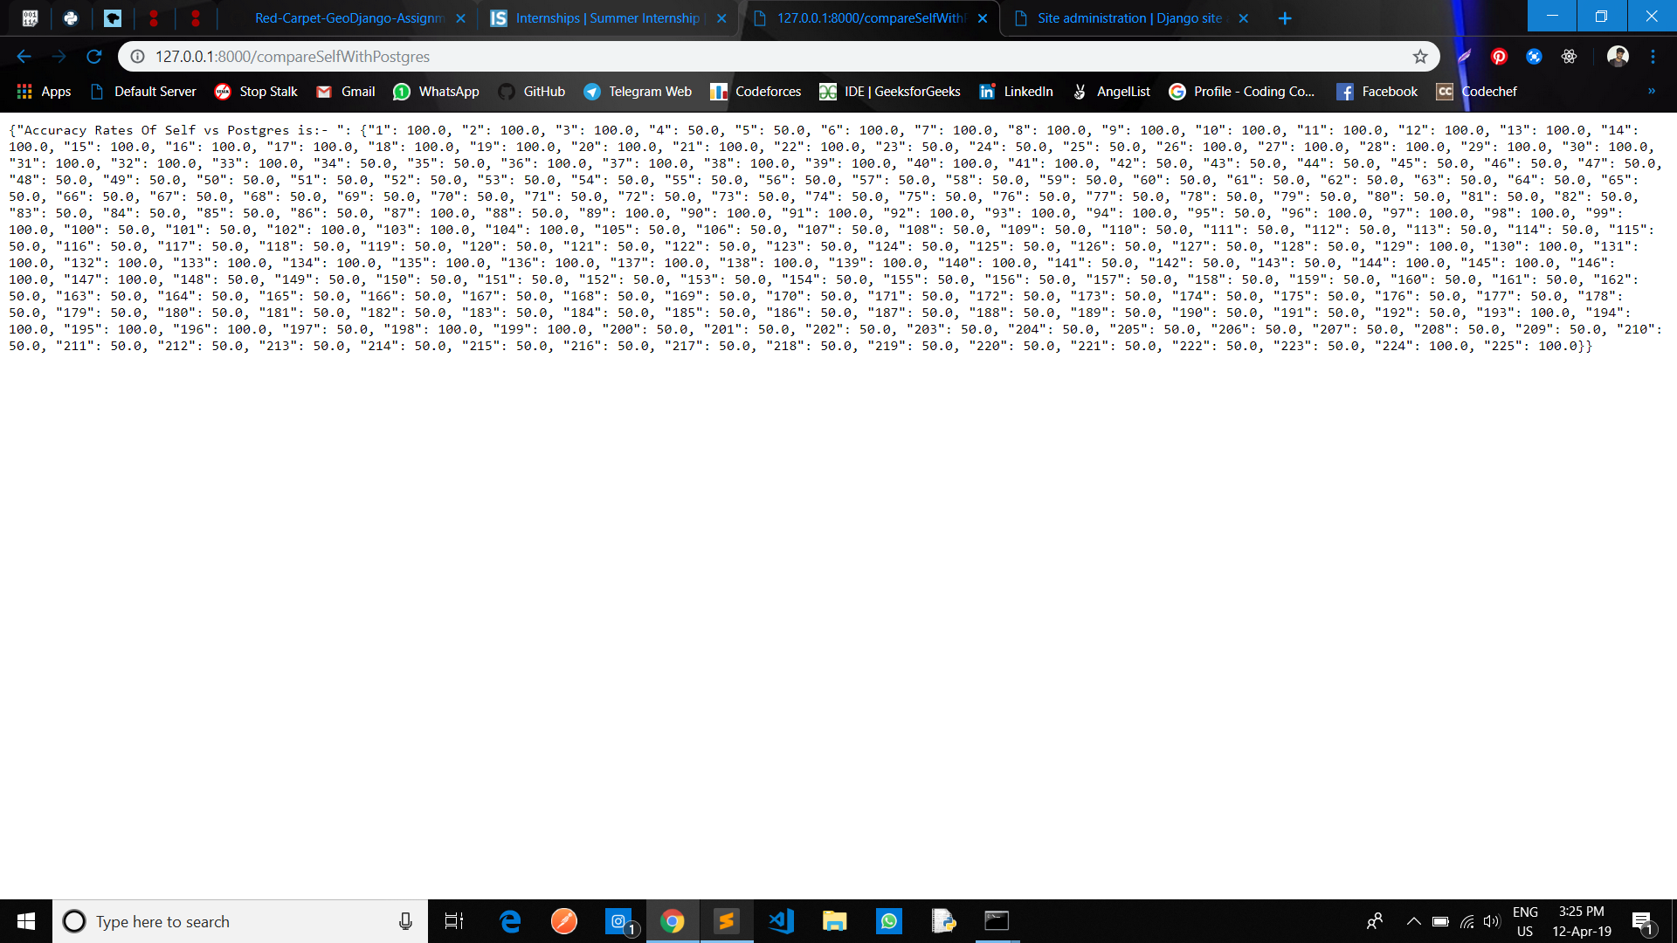

1. **On uploading the geojson file the database looks like:-**

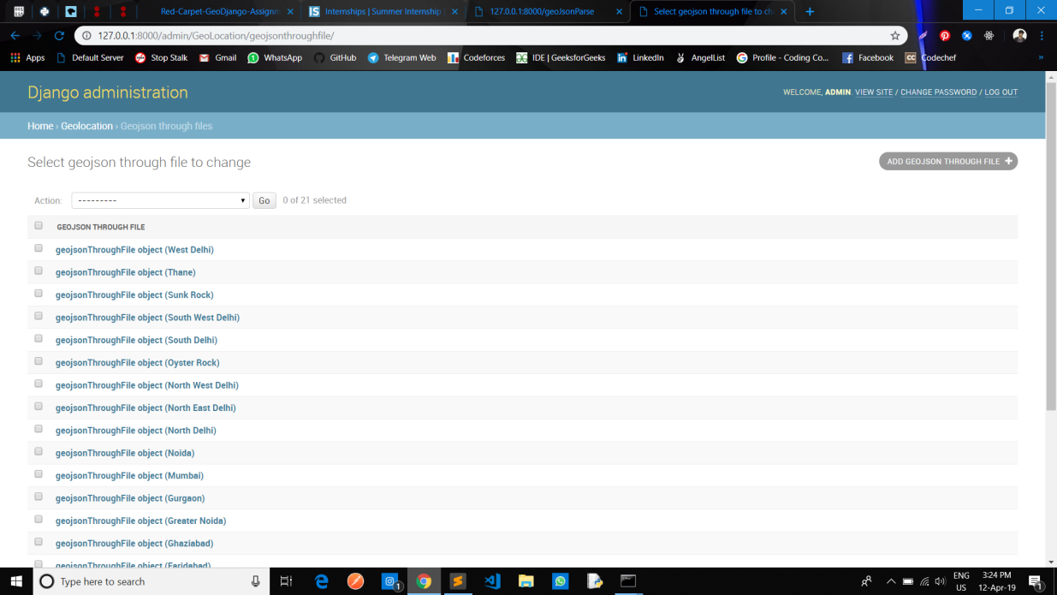

**Each entry looks like:-**

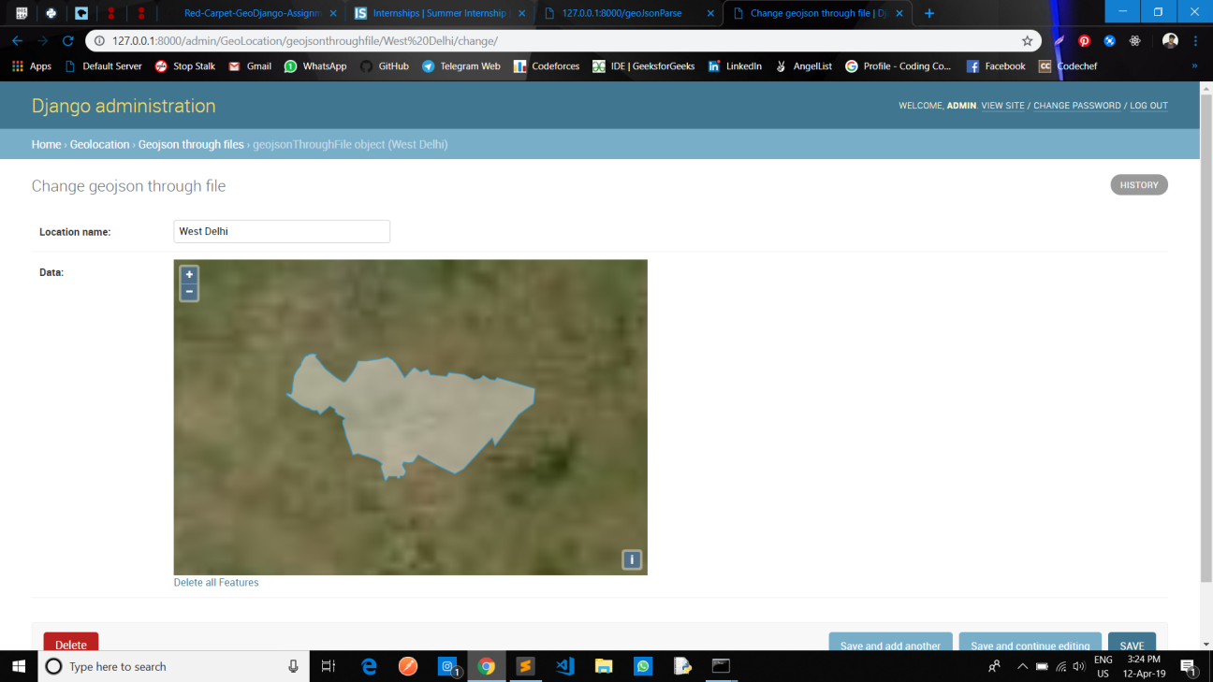

1. **Then on visiting the end point:- / latitude_longitude with query parameter:- ?latitude=76.97596549987793&longitude=28.822755894706358**

**The result will be:-**

